***North Western University, Khulna***



**Project Title: Campus Network Design**

**Course Title: Computer Networking Sessional**

**Course code: CSE-3304**

**Department: Computer Science and Engineering**

**Student Name & ID:**

|  |  |
| --- | --- |
| **Student Name** | **Student ID** |
| **Sajib Bhattacharjee** | **20201070010** |

**Name of the course teacher: Abu Naim Khan.**

**Remarks:**

**Executive Summary**

This Campus Network Scenario is about designing a topology of a network that is a LAN (Local Area Network) for a College in which various computers of different departments are set up so that they can interact and communicate with each other by interchanging data. To design a networking scenario for a college that connects various departments to each other’s, it puts forward communication among different departments. CNS is used to design a systematic and well-planned topology, satisfying all the necessities of the college (i.e. client). CNS come up with a network with good performance.

Campus networking via wireless connection becomes an important part of campus life and provides the main way for teachers and students to access educational resources, which gives an important platform to exchange information. As laptops and intelligent terminals are widely used, the demand for access to information anytime and anywhere has become more and more urgent, but traditional cable networks cannot meet this requirement. The wireless network construction becomes necessary and essential. The wireless network is one of the important components of a digital campus and wisdom campus. It provides an efficient way to explore the internet with a mobile terminal for teachers and students regardless of cables and places. This is an important mark of the modern campus as a supplement of a cable network. With the development of network and communication technology, cable networks on a university campus bring much convenience for teaching and research work. But for mobility and flexibility, it has obvious shortcomings. A wireless network can overcome these drawbacks and has been applied to the university campus.

**Table of Contents Page No.**

|  |  |  |
| --- | --- | --- |
| 1. | Cover Page | 01 |
| 2. | Executive Summary | 02 |
| 3. | Table of Contents | 03 |
| 4. | List of Figures | 03 |
| 5. | List of Tables | 03 |
| 6. | Introduction | 03 |
| 7. | Description | 04 |
| 8 | Discussion | 06 |

**List of Figure Page No.**

|  |  |  |
| --- | --- | --- |
| 1. | Campus Network Design | 05 |

**List of Tables**

I did not use any table content in this project.

**1. INTRODUCTION**

1.1. Goals and Objectives of the project

Computer networks have a significant impact on the working of an organization. Universities depend on the proper functioning and analysis of their networks for education, administration, communication, e-library, automation, etc. An efficient network is essential to facilitate the systematic and cost-efficient transfer of information in an organization in the form of messages, files, and resources. The project provides insights into various concepts such as topology design, IP address configuration, and how to send information in the form of packets to the wireless networks of different areas of a University.

The new system planned comprises IP-based switches that remain as the access point to lan-based (ethernet) as well as Wi-Fi-based connectivity. These switches provide SNMP support as well so that traffic monitoring becomes easy. Ip-based switches are used mainly because:

**1.2. Terms, Acronyms, and Abbreviations Used**

**Abbreviations**

CNS, CCNA, CISCO, IP, ROUTER, VLAN

MSE-Mobility Service Engine

UCS- Unified Computing System

RFP- Request For Proposal

IP -Internet Protocol

RIP -Routing Information Protocol

RPP- Routing Protocol Plan

OS- Operating System

**2. Description**

**2.1 Detailed explanation.**

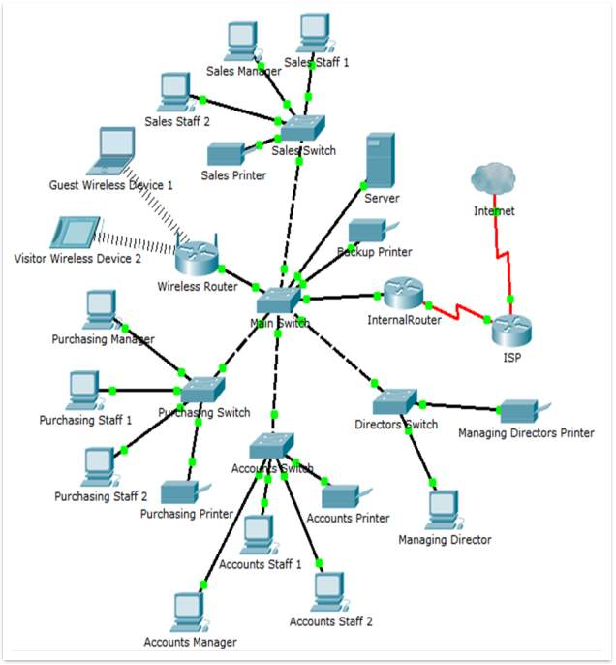

**Fig name: Campus Network Design**

Both small and large enterprise campuses require a highly available and secure, intelligent network infrastructure to support business solutions such as voice, video, wireless, and mission-critical data applications. The use of hierarchical design principles provides the foundation for implementing campus networks that meet these requirements. The hierarchical design uses a building block approach leveraging a high-speed routed core network layer to which are attached multiple independent distribution blocks. The distribution blocks comprise two layers of switches: the actual distribution nodes that act as aggregators, and the wiring closet access switches.

The hierarchical design segregates the functions of the network into these separate building blocks to provide for availability, flexibility, scalability, and fault isolation. The distribution block provides for policy enforcement and access control, route aggregation, and the demarcation between the Layer 2 subnet (VLAN) and the rest of the Layer 3 routed network. The core layers of the network provider for high-capacity transport between the attached distribution building blocks.

The basis of the LAN core is Cisco Catalyst 6509 switches equipped with Cisco 720 supervisors and Virtual Switching System (VSS), as well as Cisco 4500 switches, combined in a stack with the data transmission ports at 10 Gb/s bandwidth capacity. Switches create a platform for additional services, such as content processing, firewall (the project uses the Cisco firewall), intrusion prevention system, application of IPsec security tools, the arrangement of protected VPN channels, network analysis, and acceleration of Secure Sockets Layer (SSL) connections.

Each building block within the network leverages appropriate switching technologies to best meet the architecture of the element. The core layer of the network uses Layer 3 switching (routing) to provide the necessary scalability, load sharing, fast convergence, and high-speed capacity. Each distribution block uses a combination of Layer 2 and Layer 3 switching to provide for the appropriate balance of policy and access controls, availability, and flexibility in subnet allocation and VLAN usage.

For those campus designs requiring greater flexibility in subnet usage (for instance, situations in which VLANs must span multiple wiring closets), distribution block designs using Layer 2 switching in the access layer and Layer 3 switching at the distribution layer provide the best balance for the distribution block design.

For campus designs requiring simplified configuration, common end-to-end troubleshooting tools, and the fastest convergence, a distribution block design using Layer 3 switching in the access layer (routed access) in combination with Layer 3 switching at the distribution layer provides the fastest restoration of voice and data traffic flows.

For those networks using routed access (Layer 3 access switching) within their distribution blocks, Cisco recommends that a full-featured routing protocol such as EIGRP or OSPF be implemented as the campus Interior Gateway Protocol (IGP). Using EIGRP or OSPF end-to-end within the campus provides faster convergence, better fault tolerance, improved manageability, and better scalability than a design using static routing or RIP, or a design that leverages a combination of routing protocols (for example, RIP redistributed into OSPF).

**2.2. Technology, software, and hardware used**

**Technology:**

-Cisco Packet Tracer

**Software:**

The requirements required in the CNS are as follows:

Operating System: - Microsoft Windows 10.

Adobe Flash Player.

Cisco Packet Tracer

**Hardware Used:**

-Chipset: Intel CORE i5

- Storage:1 Tera Hard Disk, RAM-8GB

- Primary Display: QVGA TFT LCD or larger, 16 Bit color or Better

- Mouse

- Keyboard

**3. Discussion**

Tarumanagara University enhancing the Local Area Network to accommodate their needs. Using

The top-down network design process is to find the people for whom the network will provide

Services and from whom you should get valuable information to make the design succeed. The first

focus is to provide a high availability backbone in the network, redundant links, and fast link

failure detection and failover inside the routing protocol are required four buildings need to be

interconnected. The building block components hierarchical structure network are the core

layer, the distribution layer and the access layer. Core layer is designed with redundant device

using Layer 3 switch , Distribution layer at each building is design with using Layer 3 switch and

Access layer is design with using layer 2 switch. Implement Network Management Systems need

for Fault Management and Performance Management, enhanced functionality for data analysis,

reporting, notification and escalation. Furthermore, the Intrusion Detection System

implementation is discussed to address network security concerns

Tarumanagara University enhancing Local Area Network to accommodate their needs. Using

The top-down network design process to find the people for whom the network will provide

services and from whom you should get valuable information to make the design succeed. First

focus is to provide a high avalability backbone in the network, redundant link and a fast link

failure detection and failover inside the routing protocol is required four buildings need to be

interconnected. The building block components hierarchical structure network are the core

layer, the distribution layer and the access layer. Core layer is designed with redundant device

using Layer 3 switch , Distribution layer at each building is design with using Layer 3 switch and

Access layer is design with using layer 2 switch. Implement Network Management Systems need

for Fault Management and Performance Management, enhanced functionality for data analysis,

reporting, notification and escalation. Furthermore, the Intrusion Detection System

implementation is discussed to address network security concerns

To improve the campus network service, this paper proposed a Smart Campus network design (SCND) by assimilating internet of thing devices with classically network devices. Each smart device is registered to an IoT server or home getaway and controlled by a legitimate user. This design also includes Hierarchical Network Design as a hierarchical design is used to group devices into multiple layers. This paper also presents about Microcontroller unit (MCU) that is used to interconnect different IOE devices and control them by coding. To design the proposed campus network design I used cisco packet tracer simulator software.